**CIT 352 Chapter 8**

Name: Celeste George

Complete all Projects by executing every step in each project. For those steps listed below, follow the specified instruction.

Project 8-1

Step 5:

* If you do not see the GRUB2 boot screen, press ESC key when the following screen appears.

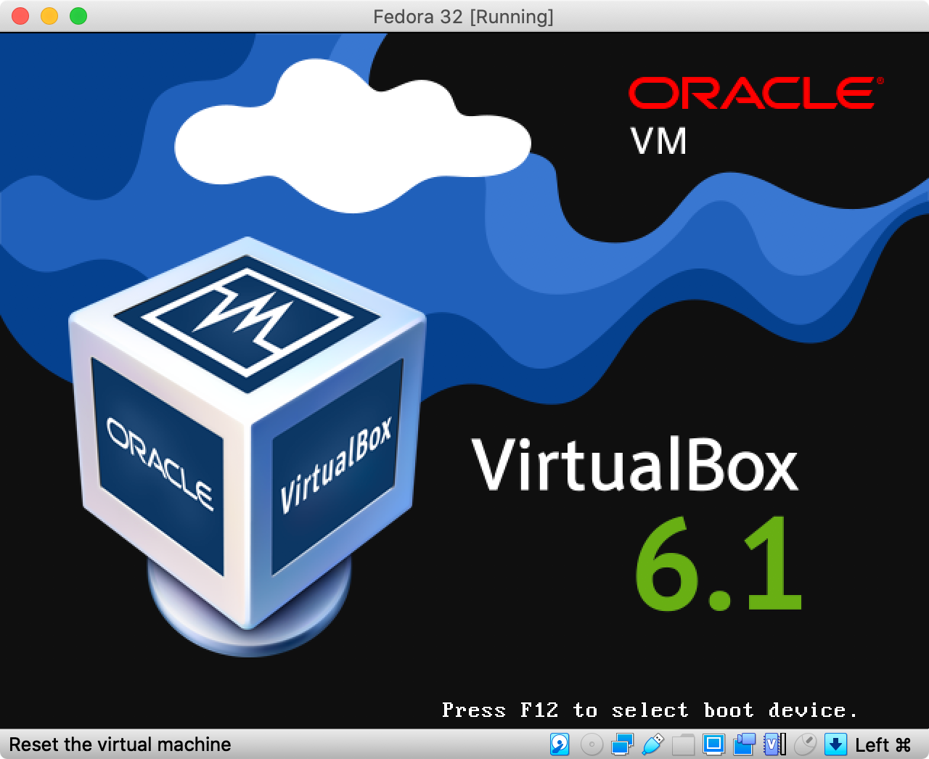

Step 10

* Insert the screen capture

Project 8-2

Step 3

* Why is /etc/inittab not used in Fedora 28?

The system uses “targets” instead of “runlevel”.

Step 12

* Insert the screen capture

Project 8-3

Step 5: You may need to extend the number of lines to display by tail command to see the log entries for the bootscript.service

Step 6

* Insert the screen capture

Project 8-4

Step 6

* Insert the screen capture

Project 8-5

Step 8

* You may get a command not found for system-config-keyboard. If you are on Fedora 28, you can install it by running the command “yum install system-config-keyboard” That package does not exist on Fedora 32, but you can change the keyboard settings by searching for “Region & Language” in the GUI.

Step 12

* Insert the screen capture

**Command Reference** (List all new commands you learned in this chapter)

Timedatectl

Locale -a | less

Init 5

Init 3

Runlevel

Journalctl | tail